East Cheshire
CHESS Club

NEWSLETTER # 23, 19th April 2017
Forthcoming events
1. East Cheshire End-of-Season Social Evening on Wed May 10th 2017
With this season ending only in the first week of May, when the A-team plays its final match, the end-of-season social evening will also be a little further into the spring than previously. We hope you can come! If you do, please bring along some food/drink to share, and if at all possible arrive by 7.30 so we can start the usual rapidplay (5 or 6 games, 10 mins each per game) promptly at 7.45 p.m. We’ll have a break for refreshments as usual around halfway through.

2. East Cheshire Chess Club Annual General Meeting
We plan to hold the club AGM on the following Wednesday, which is the 17th May, starting at 7.45 pm. Please let me know of any items you want discussed at the AGM at least two weeks beforehand, so that they can be included in the Agenda.
One such item is the introduction of a constitution, a proposal made by Steve Kelly, who is willing to take on the role of Treasurer on the condition that members are willing to adopt a constitution. The proposed constitution, which follows conversations between Steve and myself, is attached as an embedded document:
If anyone has difficulty opening this, please let me know and I can send it you separately. I would suggest that the proposed document is largely just a formalization of the way the club already operates, but others may see it differently, so please take a look and come to your own conclusion…
Given that both myself as Secretary, and Bill Tait as Treasurer, are standing down and expecting to have limited involvement in the club in future, I believe that the adoption (or not) of a constitution is something which members with an ongoing involvement in the club should have the final say over, therefore I encourage you to come along to the AGM and have your say.
On a separate note, at present I am not aware of any of the team captains wishing to be replaced for next season and so am working off the assumption they are willing to continue in their roles next season (2017-2018)… if this is not correct and a new captain will be needed for whichever team, please let me know!
3. Stockport Chess League Annual General Meeting.
We still await a scheduled date for the league AGM but expect this to take place in late May – once the date is confirmed I will share with you all. Any motions for consideration at the meeting must be submitted via your club secretary (me!) at least three weeks in advance.

4. Summer Rapidplay League
Peter Taylor of the Stockport club is planning to run the Summer Rapidplay League again this year following last summer’s experiment. Given our positive experience of this initiative back then, I have provisionally said that we would expect to enter either 1 or, as per last year, 2 teams in this league. We can decide exactly how many teams to enter (if indeed any) at the AGM. If anyone already has an inclination to take part this year, do let me know.

5. Winter League Update
Our four teams have been competing in each Division of the Stockport Chess League. The A-team, in the 1st Division, lies last with 3 games to play, 2 wins adrift of Stockport B, so looks to be up against it… but could there be another Houdini act in the locker after last season?
The B-team, which in previous years has narrowly dodged relegation from Division 2, has now concluded its season, and will almost certainly finish in an excellent 2nd place having amassed 7 match wins over the season.
The C-team likewise has had a very strong season and is currently top of Division 3 with a single match to play, though likely to be overhauled by a high-quality Wilmslow team with matches in hand.
Our D-team, in the grade-limited league, has played its final game this season, and has finished last of the 4 teams in a well-contested league, only after being narrowly edged out in all the matches conceded.

6. Competitions
The Kellett Trophy competition continues until the end of the month, but with Roger Bewsick having amassed a formidable 73 points, the nearest challenger Geoff Clarke (currently on 50 points) would need an avalanche of points in the next fortnight to catch up. In the Matchplay Competition, Bill Tait is in pole position (64% from 7 games), but with Paul Bamford and Nick Flaherty also in the running. The table is shown below, correct as of 14th April. NB Would current cup-holders please return their trophies to the Secretary or to Geoff Clarke as soon as possible!

Position | Name | Games Played | Points Score | Percentage
1 | Bill Tait | 7 | 4.5 | 64
2 | Paul Bamford | 14 | 8.5 | 61
3 | Nicholas Flaherty | 5 | 3 | 60
4 | Keven Holton | 11 | 6.5 | 59
5 | Jim McKie | 15 | 8.5 | 57
6 | David Harris | 8 | 4.5 | 56
7 | Myles Heywood | 13 | 7 | 54
8 | Tudor Rickards | 18 | 9.5 | 53
9 | Steve McCall | 17 | 8.5 | 50
10 | David Taylor | 14 | 7 | 50
11 | Geoff Clarke | 10 | 5 | 50
12 | Geoff Smith | 9 | 4.5 | 50
13 | Steve Kelly | 8 | 4 | 50
14 | John Reed | 8 | 3.5 | 44
15= | Kieran Newell | 9 | 3.5 | 39
15= | Geoff Brindle | 9 | 3.5 | 39
17 | Keith Hodgson | 11 | 4 | 36
18 | David Newell | 17 | 5.5 | 32
19 | Steve Tranter | 7 | 1.5 | 21

Best wishes all!

Myles Heywood (Club Secretary)

…and below are some puzzles for you to solve…

- Black to move – a subtle move is needed to turn the screw…

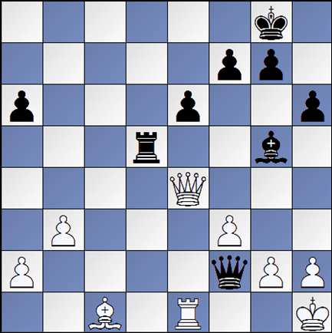

- White to move – better find a way to disrupt black’s defences before the black pawns overwhelm you…

